# Assignment 5

Consider the following schema of a relational database.

Aircraft (aid, type)

Flights (flno, aid, company)

Employees (eid, ename, salary)

Certified (eid, aid)

Schedule (eid, flno, source_city, destination_city, date)

Create table through appropriate SQL commands. Define all integrity constraints and enter sufficient data.

1. Give the name of the employee who has certification on more than 1 type of aircrafts.
2. Give the name of the employee who has no certification
3. Give the name of the city where from maximum flight takes off (source_city)?
4. Give the name of the company, which spend maximum salary for their employees.
5. Give the name of the company which has maximum types of flights.

# Solution

## Table creation

### Aircraft

create table aircraft(aid varchar2(3) primary key, type varchar2(30));

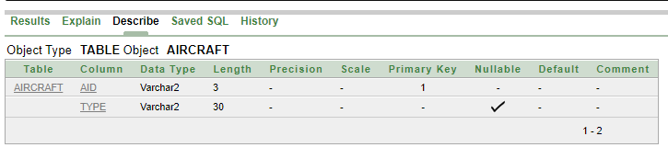

### Flights

create table flights(flno varchar2(3) primary key, aid varchar2(3), company varchar2(15), foreign key(aid) references aircraft(aid));

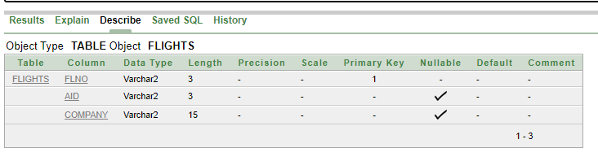

### Employees

create table employees(eid varchar2(3) primary key, ename varchar2(30), salary number(10));

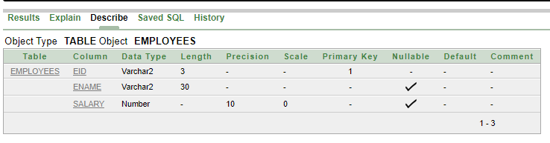

### Certified

create table certified(eid varchar2(3), aid varchar2(3),primary key(eid, aid), foreign key(eid) references employees(eid), foreign key(aid) references aircraft(aid));

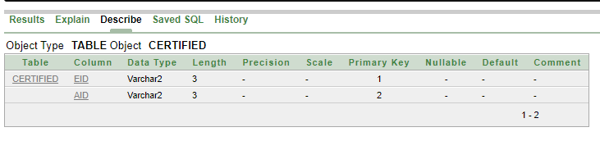

### Schedule

create table schedule(eid varchar2(3), flno varchar2(3), source_city varchar2(10), destination_city varchar2(10), sdate date,primary key(eid, flno), foreign key(eid) references employees(eid), foreign key(flno) references flights(flno));

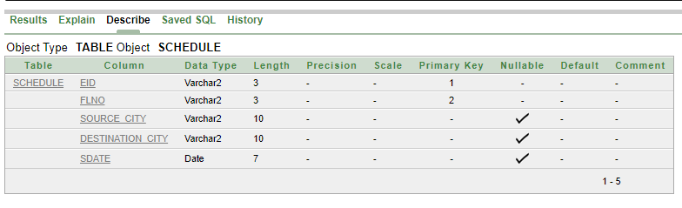

## Value Insertion

### Aircraft

insert into aircraft values('a01','Commercial airline');

insert into aircraft values('a02','Commercial airline');

insert into aircraft values('a03','Amphibian');

insert into aircraft values('a04','Business jet');

insert into aircraft values('a05','Helicoptor');

insert into aircraft values('a06','Business jet');

insert into aircraft values('a07','Military aircraft');

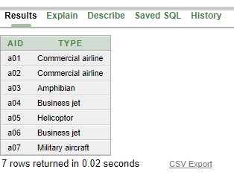

### Flights

insert into flights values('f01', 'a02', 'IndiGo');

insert into flights values('f02', 'a02', 'Air India');

insert into flights values('f03', 'a01', 'IndiGo');

insert into flights values('f04', 'a03', 'IndiGo');

insert into flights values('f05', 'a07', 'Air India');

insert into flights values('f06', 'a02', 'Jet Airways');

insert into flights values('f07', 'a02', 'SpiceJet');

insert into flights values('f08', 'a05', 'GoAir');

insert into flights values('f09', 'a04', 'Vistara');

insert into flights values('f10', 'a06', 'Deccan');

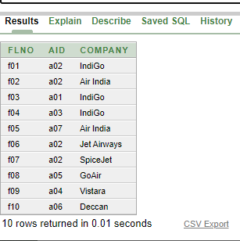

### Employees

insert into employees values('e01', 'Ayushi Roy', 700000);

insert into employees values('e02', 'Priyam Dey', 900000);

insert into employees values('e03', 'Tulika Sen', 800000);

insert into employees values('e04', 'Mishmi Paul', 400000);

insert into employees values('e05', 'Ritika Gupta', 600000);

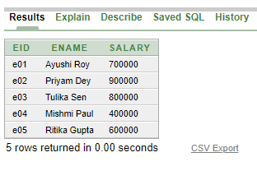

### Certified

insert into certified values('e01', 'a01');

insert into certified values('e01', 'a04');

insert into certified values('e01', 'a07');

insert into certified values('e01', 'a06');

insert into certified values('e02', 'a01');

insert into certified values('e02', 'a02');

insert into certified values('e03', 'a01');

insert into certified values('e04', 'a05');

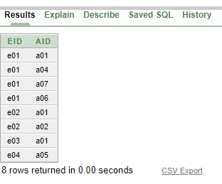

### Schedule

insert into schedule values('e01', 'f01', 'Chennai', 'Kolkata', '10-JUN-2019');

insert into schedule values('e02', 'f08', 'Chennai', 'Gujarat', '11-MAY-2016');

insert into schedule values('e05', 'f03', 'Chennai', 'Mumbai', '11-MAY-2016');

insert into schedule values('e03', 'f01', 'Kolkata', 'Delhi', '20-SEP-2015');

insert into schedule values('e01', 'f02', 'Kolkata', 'Chennai', '15-SEP-2020');

insert into schedule values('e04', 'f09', 'Delhi', 'Kolkata', '11-MAY-2016');

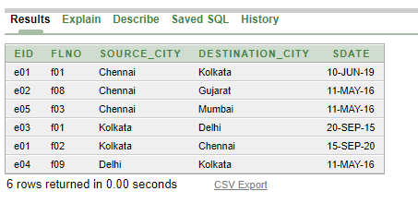

## Queries

1. *Give the name of the employee who has certification on more than 1 type of aircrafts.*

**ans.** select eid, ename from employees where eid in (select eid from certified natural join employees natural join aircraft group by eid having count(distinct(type)) > 1);

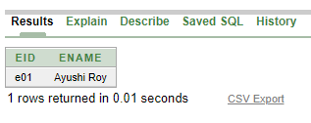

1. *Give the name of the employee who has no certification.*

**ans.** select eid, ename from employees where eid not in (select distinct eid from certified);

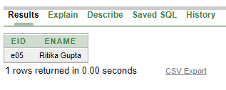

1. *Give the name of the city where from maximum flight takes off (source_city)?*

**ans.** select source_city from schedule group by source_city having count(flno) = (select max(count(flno)) from schedule group by source_city);

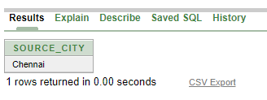

1. *Give the name of the company, which spend maximum salary for their employees.*

**ans.** select company from schedule natural join employees natural join flights group by company having sum(salary) = (select max(sum(salary)) from schedule natural join employees natural join flights group by company);

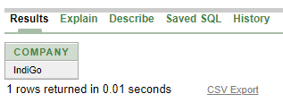

1. *Give the name of the company which has maximum types of flights.*

**ans.** select company from flights natural join aircraft group by company having count(distinct(type)) = (select max(count(distinct(type))) from flights natural join aircraft group by company);

